INDIVIDUAL LAB-WORK RECORD
ASSIGNMENT 2
Scenario 2: Use of Test Data Driven Automation in Python Behave Framework
Student Name | ________________________
Roll No. | ________________________
Module | Data-Driven BDD / API Automation
Experiment | Scenario 2: Use of Test Data Driven Automation in Python Behave Framework
Date | ________________________

1. Problem Statement
To implement data-driven automation in Python Behave so that one reusable BDD scenario can execute against multiple datasets, and to demonstrate the approach through parameterized API validation.

2. Objective
- Understand data-driven automation.
- Use Scenario Outline and Examples in Behave.
- Pass multiple test values to common Python step definitions.
- Automate HTTP GET validation with Python Requests.
- Verify status codes and response content for multiple datasets.

3. Theory
Data-driven testing separates test data from test logic. Instead of copying the same test for every input, Behave uses a Scenario Outline with placeholders. Rows in an Examples table are substituted into the placeholders and Behave creates an iteration for every row. This is useful for API, login, form and validation testing.
- Scenario Outline defines the reusable workflow.
- Examples stores multiple input/expected-output rows.
- Placeholders such as <url> are replaced at runtime.
- Requests sends HTTP requests from Python.
- Assertions decide whether each data iteration passes or fails.

4. Tools, Software and Concepts Used
- Python 3.x
- PyCharm Community
- Behave
- Requests library
- Gherkin
- Scenario Outline and Examples
- REST API
- HTTP status-code verification

5. Environment Setup

5.1 Installation
python -m venv venv
.\venv\Scripts\Activate.ps1
pip install behave requests

5.2 Folder Structure
assignment2/
└── features/
├── api_data.feature
└── steps/
└── api_steps.py

6. Implementation

6.1 Data-Driven Feature - api_data.feature
Feature: Data driven API automation
Scenario Outline: Verify GET endpoint
Given I send a GET request to "<url>"
Then the status code should be <code>
And response text should contain "<text>"
Examples:
| url | code | text |
| https://example.com | 200 | Example Domain |
| https://httpbin.org/get | 200 | url |

6.2 Step Definitions - api_steps.py
from behave import given, then
import requests
@given('I send a GET request to "{url}"')
def send_get(context, url):
context.response = requests.get(url, timeout=10)
@then("the status code should be {code:d}")
def check_status(context, code):
assert context.response.status_code == code
@then('response text should contain "{text}"')
def check_text(context, text):
assert text in context.response.text

7. Optional External Data Concept
For larger test suites, data may be maintained in CSV/JSON and loaded in Python. The assignment specifically asks for a test-data-driven approach; the Scenario Outline above is the native Behave implementation, while external files are an extension.

7.1 Sample CSV
url,code,text
https://example.com,200,Example Domain
https://httpbin.org/get,200,url

8. Execution Steps
- Start the virtual environment.
- Run `behave -f pretty`.
- Observe one scenario iteration per Examples row.
- Verify the GET response status and content.
- Change one expected value deliberately to understand assertion failure, then restore it.
- Capture the terminal output and, if desired, API response evidence.

9. Output Screenshot 1 - Data-Driven Behave Result
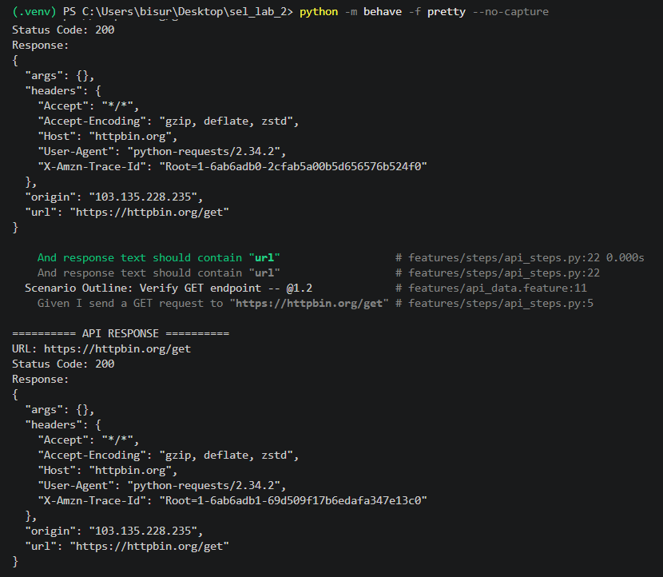

10. Output Screenshot 2 - API Response / Validation
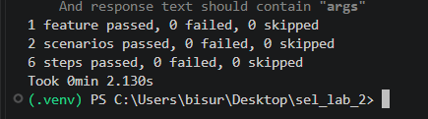

11. Expected Output
Each Examples row should execute independently and show its own step status. With reachable endpoints and correct expected values, all iterations should pass.

Result
A parameterized Behave scenario was implemented for multiple API test datasets and validated through Python Requests assertions.

Observation
One test workflow can validate several datasets without duplicating step definitions. New cases can be introduced mainly by adding data rows.

Conclusion
The experiment demonstrates how data-driven BDD improves reusability, consistency and test coverage.

